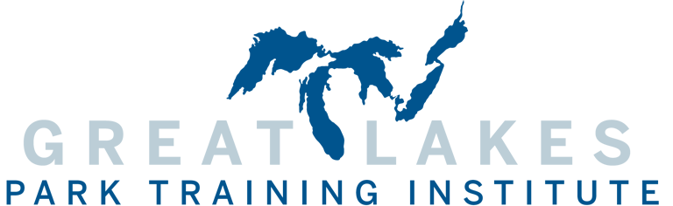

2024 Garrett G. Eppley Scholarship Application
Applicant Contact Information
Name
Title
Agency
Street
City | State |  | Zip
Phone |  | Fax
Email
Applicant Professional Profile
How many years have you been employed in the Parks and Recreation field? ___

Please attach your resume to this application.

Have you ever attended the Great Lakes Park Training Institute? ___Yes ___No
Please describe your future or career goals for the next 5 years (up to 100 words):
Please write a short paragraph demonstrating why you would like to attend GLPTI and how you believe it will benefit your career (up to 100 words):

By submitting this application, applicants acknowledge that winners will need to donate volunteer time to the 2024 Great Lakes Park Training Institute. Hours and specific duties will be established between the applicant and the Board of Advisors of the Institute. Prior year scholarship winners not eligible. Please mark the box below to acknowledge these requirements.
□ (Check here)

Scholarship winners will be awarded up to $1000 toward full 2023 Institute cost of attendance including registration, lodging and meals, and travel. Deadline to apply for the 2024 Institute is November 30, 2023.

Please email this application and a copy of your resume to:
Layne Elliott, Assistant Director
Great Lakes Park Training Institute
Phone: 812-855-3095
E-mail: glpti@eppley.org

