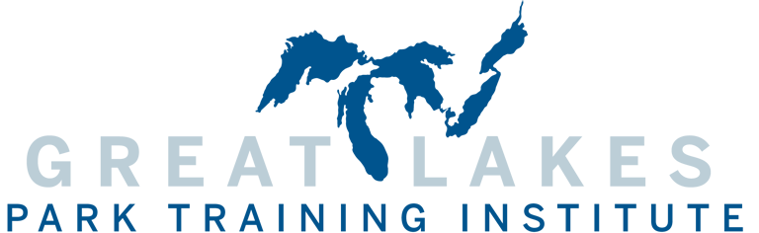

2024 Great Lakes Park, Facility, or Program Award Application

Nomination Guidelines
The Great Lakes Park, Facility, or Program Award recognizes parks, facilities, and programs completed within the last 5 years which represent the cutting edge of the leisure movement in the United States. Award winners represent innovative, cost-effective design, demonstrate the utilization of community input and resources, and provide a significant impact on their community and agency. If you have or know of a park, facility, or program within or outside your agency, please take a moment to nominate it by completing this application and returning it via email. Please submit a web link (if applicable) and no more than 8-10 digital photographs of the park, facility, or program with the application. Winners will be honored during the annual conference in February 2024.

Facility or Program Information

Park, Facility, or Program Name:
Contact Person | Title

Agency

Address
City |  | State | Zip
Phone | Fax

Email

Application Requirements

In a separate one or two page document, please type a minimum of three paragraphs that give a detailed account of the park, facility, or program that you are nominating. Be sure to include 1) Description of the park, facility, or program, 2) How the park, facility, or program utilized innovative and/or unique design approaches, 3) What type of impact this park, facility, or program project had/has on your community, 4) What efforts were made to utilize community input and/or outside resources for the project. Send this form, your document (please limit to two (2) pages), and no more than 8-10 digital photographs (required) along with a web link (optional) to glpti@eppley.org by November 30, 2023.

Award Criteria

Park, Facility, or Program Award winners will be chosen based on the following criteria:

Park, Facility, or Program Description - 5 points

Innovation and Design - 20 points

Impact on Community - 15 points

Utilization of Community Input and Resources - 10 points

**Award winners must be present at the GLPTI Awards Presentation in February 2024 to receive the award.

Deadline to apply is November 30, 2023.

Please email this application to
Layne Elliott, Assistant Director
Great Lakes Park Training Institute
2805 E 10th St, Suite 170
Bloomington, IN 47408
Phone: 812-855-3095
E-mail: glpti@eppley.org

