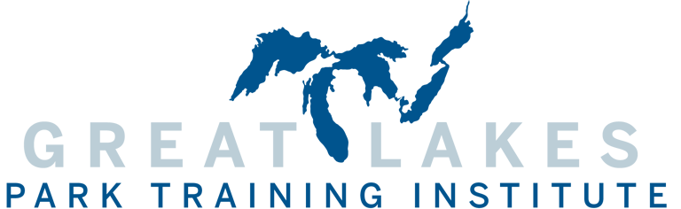

2024 Richard Lawson Award for Professional Excellence Application

Nomination Guidelines
Given annually by the GLPTI Board of Advisors, this award is presented to individuals who exemplify continued and significant contributions to the parks and recreation profession in the Great Lakes region. If you know of an individual who has made a significant difference in parks and recreation in the Great Lakes region, please take a moment to nominate them by completing this application and returning it via email. The award winner will be honored during the annual conference in February 2024.

Nominator Information
Your Name | Title

Agency

Address
City | State | Zip
Phone | Fax

Email

Nominee Information
Nominee’s Name | Title

Agency

Address
City | State | Zip
Phone | Fax

Email

Application Requirements

In addition to the information provided above, in separate document please type a minimum of four paragraphs that give a detailed account of the person who you are nominating.

Be sure to include a description of their work and how it has influenced parks and recreation in the Great Lakes region.

Deadline to apply is November 30, 2023.

Please email this application and supporting documentation to:
Layne Elliott, Project Manager
Great Lakes Park Training Institute
2805 E 10th St, Suite 170
Bloomington, IN 47408
Phone: 812-855-3095
E-mail: glpti@eppley.org

